**Computer Science 2212b**

**Team Assignment 1**

**Team 4**

Due Date: **Feb, 14, 2014**

**Team Members:**

Zaid Albirawi

Justin Cheng

Steve Juarez

Jenna Le

Mikhail Lebedzeu

**Personal Snapshots**

**Zaid Albirawi**

Zaid Albirawi is familiar with several functional and object oriented programming languages, such as VB, Java, UNIX, C, ARM assembly, C#, and scheme. He is also familiar with the web-development languages, CSS3 and HTML5, and is knowledgeable with MS Office Suite and Adobe Suite. Previous work related experience include developing, designing, and managing websites, as well as developing computer software. Zaid is comfortable with complex algorithms, data structures, and computational problems.  
  
**Justin Cheng**

Justin is a self-driven individual with an insatiable appetite for knowledge. He enjoys collaborating with like-minded individuals and is waiting for the prime opportunity to showcase his creativity. He is proficient in several programming languages including Java, C, UNIX, and ARM programming. Justin is always ready to take on any challenge with an open mind and a relentless spirit.  
  
**Steve Juarez**

Steve is a self-motivated learner, always open to new ideas and learning from others. Previous unrelated work and volunteer experience have developed his time management and organization skills. Steve is an effective communicator, analytical in nature, and loves problem solving. Steve is familiar with Java and C, and feels comfortable approaching all stages of project development.  
 **Jenna Le**

Jenna is familiar with Java, C, and UNIX languages. She also has a background in web/media design, and so is versed in HTML/CSS, JavaScript/Jquery, PHP, and the Adobe Creative Suite. Currently, Jenna is working at the Instructional Technology Resources Centre (ITRC) on campus, where she has learned to become very familiar with OWL Sakai; and more specifically, the OWL Gradebook interface. Jenna hopes to apply her interest in UI Design and experiences with OWL Gradebook support (ie. professor testimonials) to our groups’ project.

**Mikhail Lebedzeu**

Mikhail is an efficient programmer who specializes in Java. He enjoys the structured nature of larger programs and loves attention to detail. His coding experience dates 5 years, where he has worked on a vast array of different programs. Mike is familiar with C, UNIX, Python, HTML, ARM, XML, SQL programming languages. He learns very quickly and is well versed in a large variety of computer software.

**User Stories**Link:https://www.pivotaltracker.com/s/projects/1010498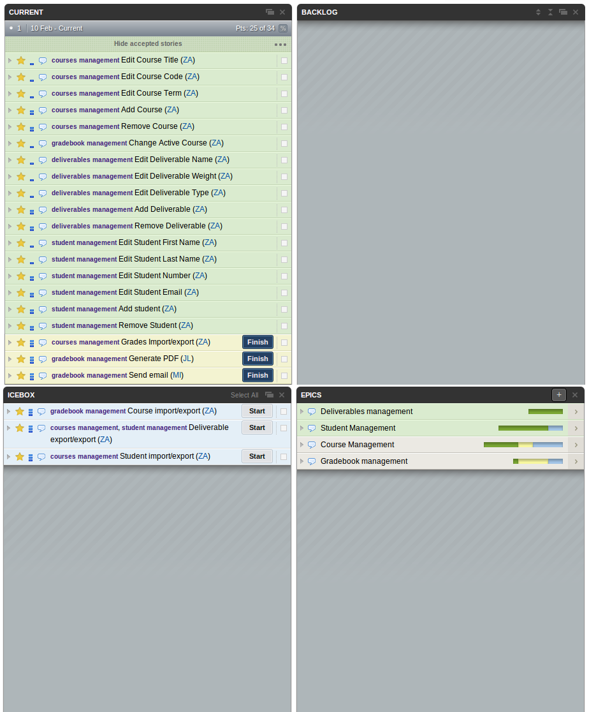

**UML Class Diagram**

**Project Plan**

